Images, Graphs, and Results

Diabetes exploratory data analysis

Relationship between different parameters and chances of having diabetes

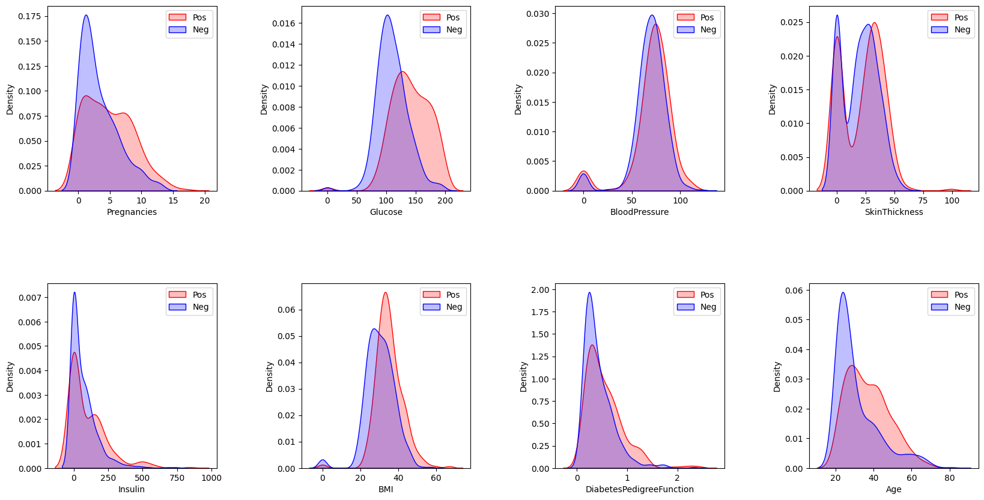

Relationship between each pair of parameters
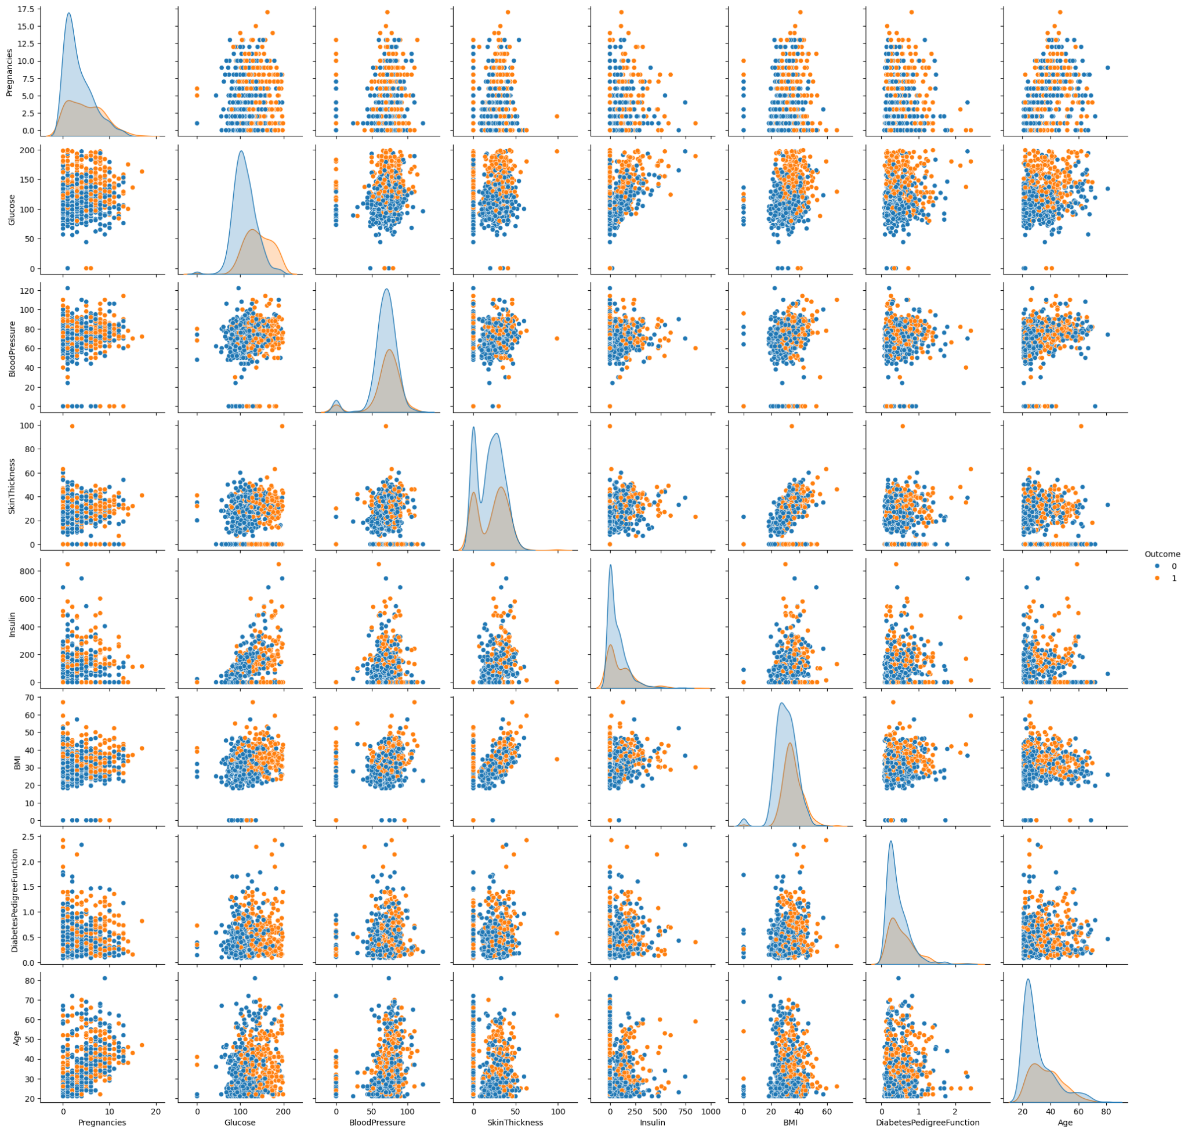

Correlation map

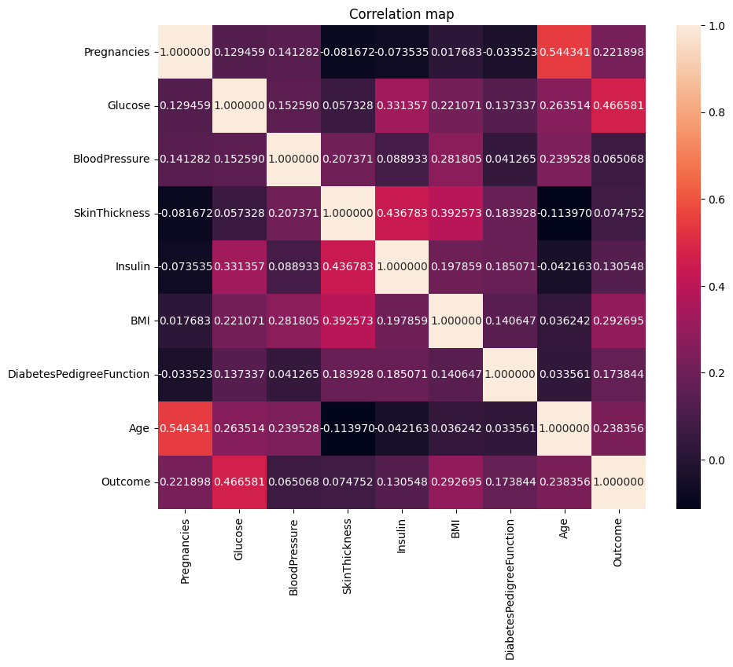

Diabetes prediction using different algorithms

Diabetes KNN confusion matrix
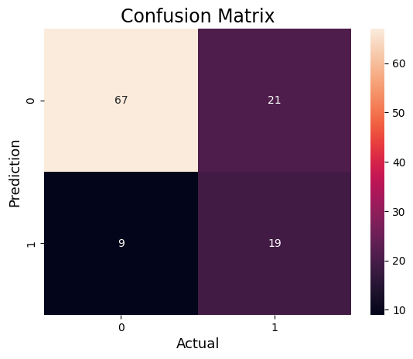

Diabetes Random Forset confusion matrix
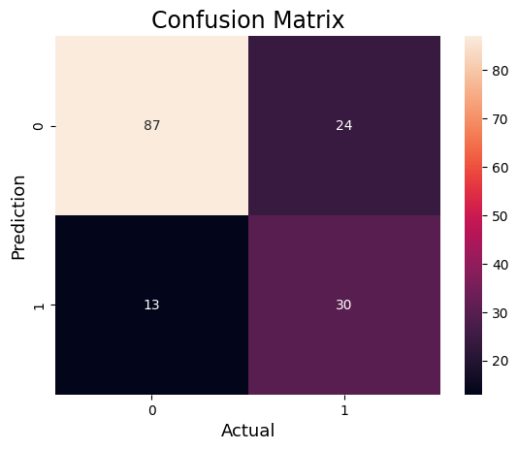

Diabetes SVM confusion matrix
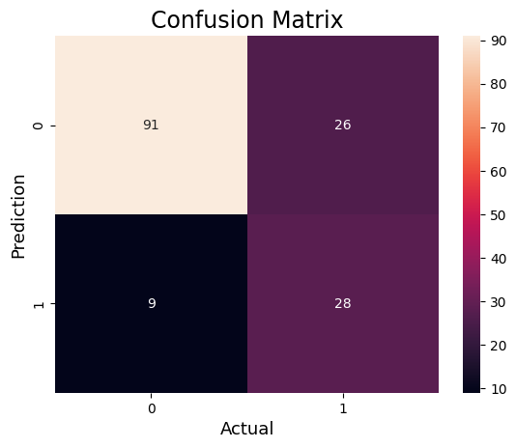

Diabetes KNN results
precision recall f1-score support

0 0.88 0.76 0.82 88
1 0.47 0.68 0.56 28

accuracy 0.74 116
macro avg 0.68 0.72 0.69 116
weighted avg 0.78 0.74 0.75 116

Diabetes random forest results

precision recall f1-score support

0 0.87 0.78 0.82 111
1 0.56 0.70 0.62 43

accuracy 0.76 154
macro avg 0.71 0.74 0.72 154
weighted avg 0.78 0.76 0.77 154

Diabetes SVM results
precision recall f1-score support

0 0.91 0.78 0.84 117
1 0.52 0.76 0.62 37

accuracy 0.77 154
macro avg 0.71 0.77 0.73 154
weighted avg 0.82 0.77 0.79 154

Diabetes Comparison between all 3 algorithms

For unaffected patients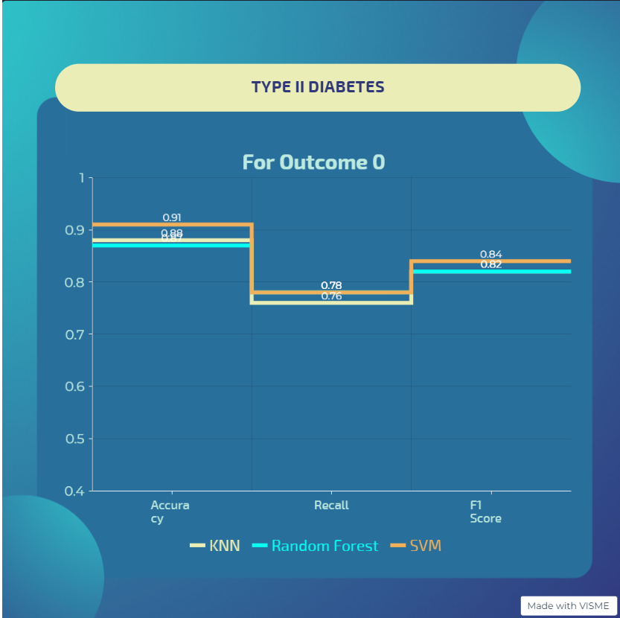

For affected patients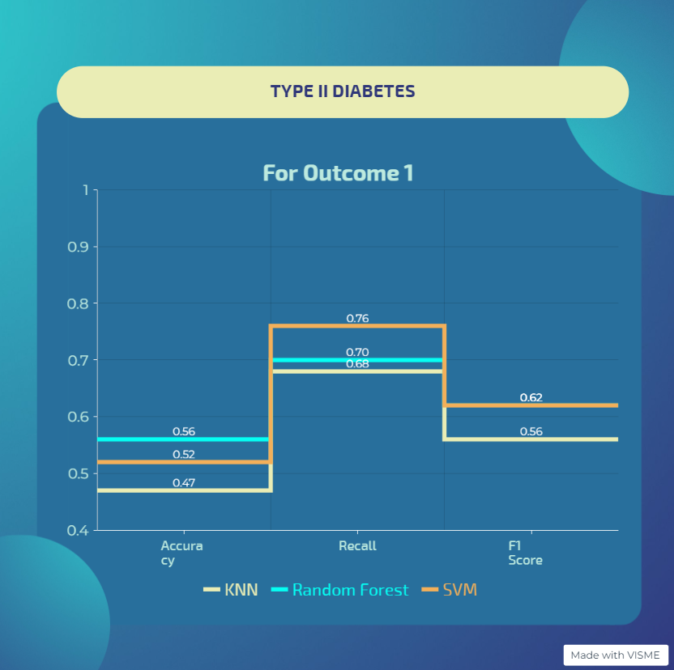

IBD Exploratory Data Analysis

Genotype density distribution for first 25 sample patients
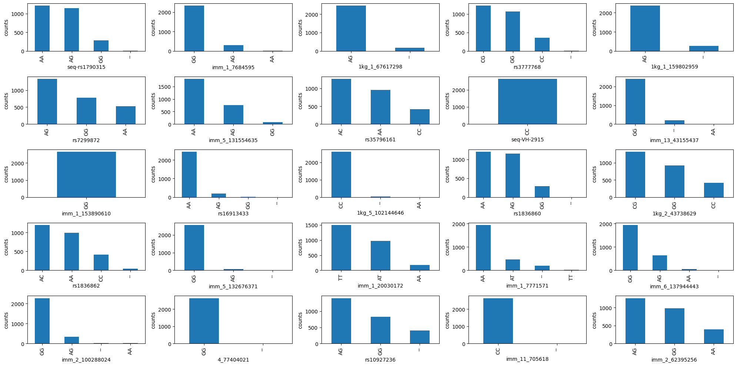

Distribution of SNPs after cleaning
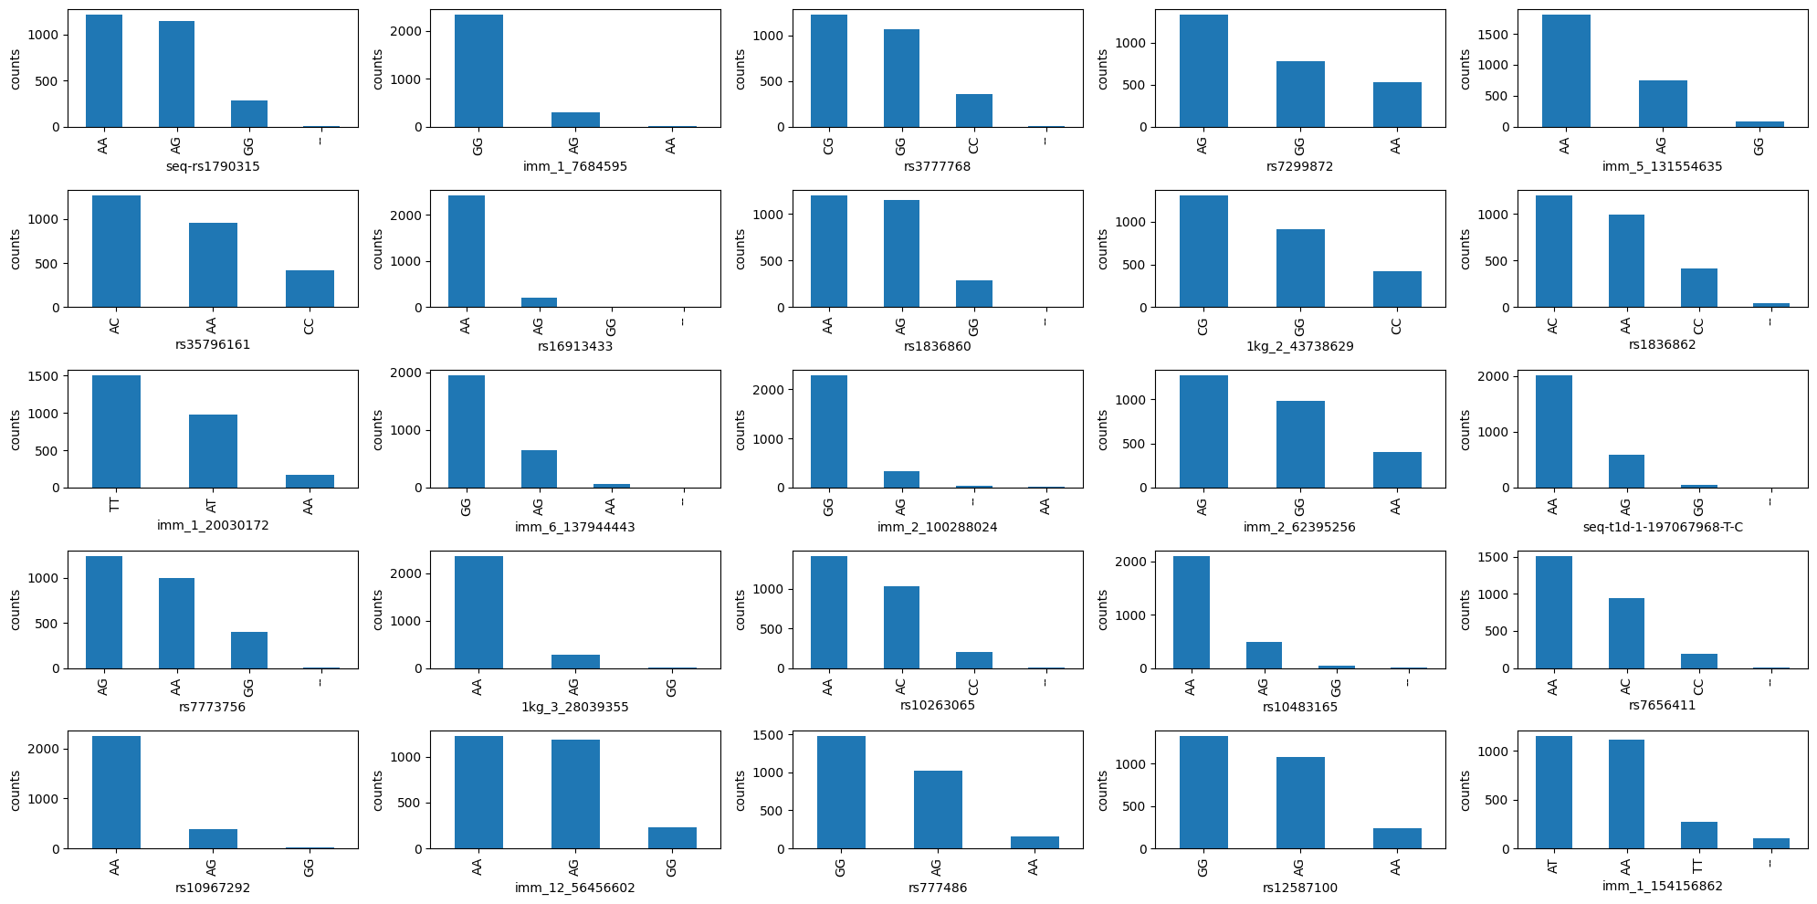

Observations:
Now the distribution looks a lot more even. Most columns have 3 biallelic variants, whose frequency decreases monotonically. However, there are still a few left with missing values, so we will use some additional feature selection methods.

Manhattan Plot

run data cleaning pipeline and generate manhattan plot

IBD Heatmap
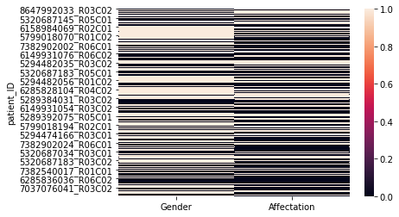

IBD Prediction using 3 Algorithms

IBD Logistic Regression ROC Curve

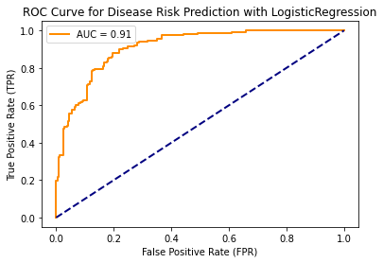

IBD Random Forest ROC Curve

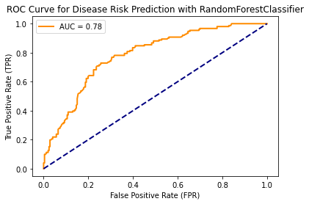

IBD SVM ROC Curve
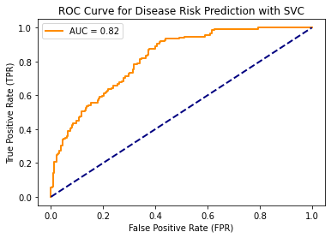

IBD Logistic Regression result
precision recall f1-score support

0 0.87 0.86 0.87 246
1 0.78 0.79 0.79 151

accuracy 0.84 397
macro avg 0.83 0.83 0.83 397
weighted avg 0.84 0.84 0.84 397

IBD Ramdom Forest result
precision recall f1-score support

0 0.73 0.85 0.78 246
1 0.66 0.48 0.56 151

accuracy 0.71 397
macro avg 0.69 0.66 0.67 397
weighted avg 0.70 0.71 0.70 397

IBD SVM result

precision recall f1-score support

0 0.78 0.75 0.76 246
1 0.61 0.66 0.63 151

accuracy 0.71 397
macro avg 0.70 0.70 0.70 397
weighted avg 0.72 0.71 0.71 397

IBD Logistic Regression confusion matrix

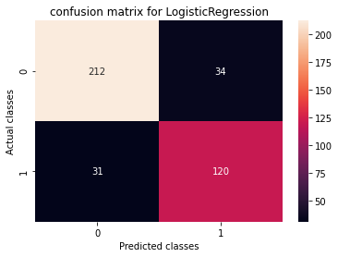

IBD Random Forsest confusion matrix

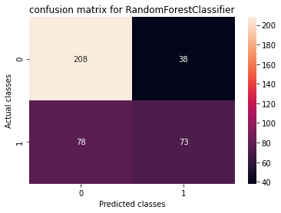

IBD SVM confusion matrix

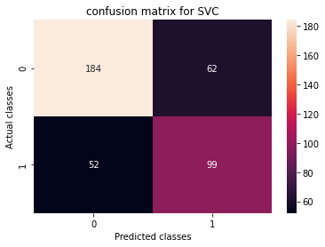

IBD Comparison between all 3 algorithms

For unaffected patients
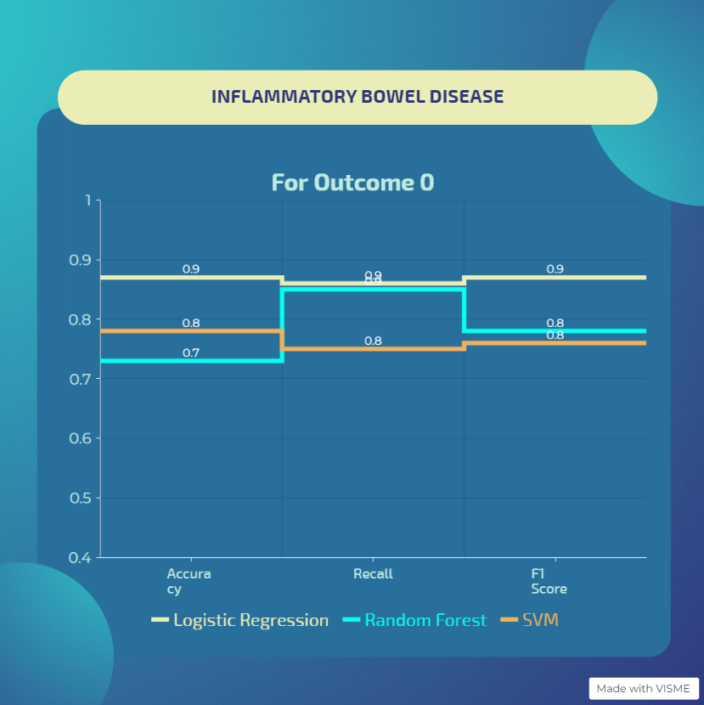

For affected patients
